
Regulations:
A15
Sreenidhi Institute of Science and Technology
(An Autonomous Institution)
Code No:5H678 Date:5-Dec-16 (FN)
MBA II-YEAR I–SEMESTER, Nov/Dec 2016 (Regular/Supple.)
QUANTITATIVE APTITUDE AND LOGICAL REASONING
Time: 3 Hours Max. Marks: 75

Note: a) No additional answer sheets will be provided.
b) All sub-parts of a question must be answered at one place only, otherwise it will not be valued.
c) Assume any missing data

Part – A
Max. Marks: 25
Answer all the QUESTIONS
      - In a certain code GERMINATION is written as IMGRENNOAIT. How is ESTABLISHED written in that code? 2M
      - What percent of 50 is 2? 2M
      - N5V, K7T, ?, E14P, B19N. 2M
      - A sum of money trebles itself in 20 years at Simple Interest. Find the rate of interest? 2M
      - If x:y=3:4, Find (4x+5y): (5x-2y). 2M
      - Ravi left home and cycled 10 km towards south ,then turned right and cycled 5km and then again turned right and cycled 10km. After this he turned left and cycled 10km. How many kilometers will he have to cycle to reach his home straight? 3M
      - Rita told Mani, “ The girl I met yesterday was the youngest daughter of the brother in law of my friend’s mother.” How is the girl related to Rita ‘s friend? 3M
      - If a radio is purchased for Rs.520 and sold for Rs.510.50. Find the loss percentage. 3M
      - Draw Venn diagram to represent Teacher, Writer and Musician. 3M
      - The product of two numbers is 120 and the sum of their squares is 289. Find the sum of the numbers. 3M

Part – B
Max. Marks: 50
ANSWER ANY FIVE. ALL QUESTIONS CARRY EQUAL MARKS.

- Five friends P, Q, R, S and T travelled to five different cities of Chennai, Kolkata, Delhi, Bangalore and Hyderabad by different modes of transport of Bus, Train, Aeroplane, Car and Boat from Mumbai.
The person who travelled to Delhi did not travel by boat.
R went to Bangalore by car and Q went Kolkata by aeroplane
S travelled by boat whereas T travelled by train.
Mumbai is not connected by bus to Delhi and Chennai.
- T goes by Which mode.
- Who goes to Chenai.
- Name the place and the mode of transport for the person R.
- The person travelling to Delhi went by which mode.
- Who travelled to Delhi.
2 a) Find the angle between the hour hand and the minute hand of a clock when time is 4:50 PM.
b) What was the day on 10th May 2003.

3. a) Find the HCF and LCM of 2/3, 8/9, 16/81 and 10/27.
b)The average of 25 results is 18. The average of first 12 is 14 and the last 12 is 17. Find the 13th
result.

4. a) An alloy contain copper and zinc in the ratio 9:4. Find the zinc required to be melted with 24kg of copper ?
b) A, B and C start a business each investing Rs.20,000/-. After 5 months A withdrew Rs.5000/-, B withdrew Rs.4000/- and C invest Rs.6000/- more. At the end of the year the total profit of 69900/- was recorded. Find the share of each?

5. a) A man walking at the rate of 5km/hr crosses a bridge in 15 minutes. Find the length of the bridge.
b) If the simple interest on the sum of money at 5% per annum for 3 years is 1200/-. Find the compound interest for the same sum for the same period at the same rate.

6 . The bar graph gives below shows the foreign exchange reserves of a country (million US $) from 1991-92 to 1998-99. Answer the questions based on the graph.
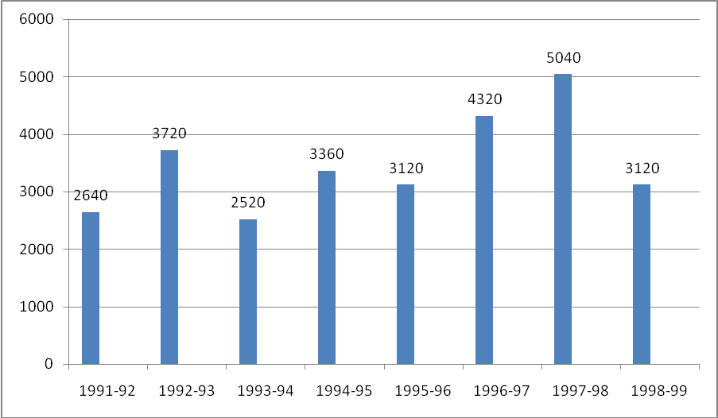
- The foreign exchange reserves in 1997-98 was how many times that in 1994-95 ?
- 0.7 B) 1.2 C) 1.4 D) 1.5
- What was the percentage increase in the foreign exchange reserves in 1997-98 over 1993-94?
A) 100 B) 150 C) 200 D)620
iii) For which year the percent increase in the foreign exchange reserves over the previous year is the highest?
A) 1992-93 B) 1993-94 C) 1994-95 D) 1996-97
iv) The ratio of the number of years, in which the foreign exchange reserves are above the average reserves to those in which the reserves are below the average reserves is
A)2:6 B) 3:4 C)3:5 D) 5:3

7) a )The diagonals of two squares are in the ratio 2:5. Find the ratio of their areas?
b) Find the number of lead balls each 1 cm in diameter that can be made from a sphere of diameter 12cm ?
-- 00 -- 00 –

